**Roll No:- 97**

**Name:-PATIL SWATI VINAYAK**

**Assignment No:-2.1**

**Assignment:-Develop program to learn different types of structures in python(Repetition statement).**

* **For loop using range ():-**

for x in range(5):  
 print(x)

* + **Output:-**

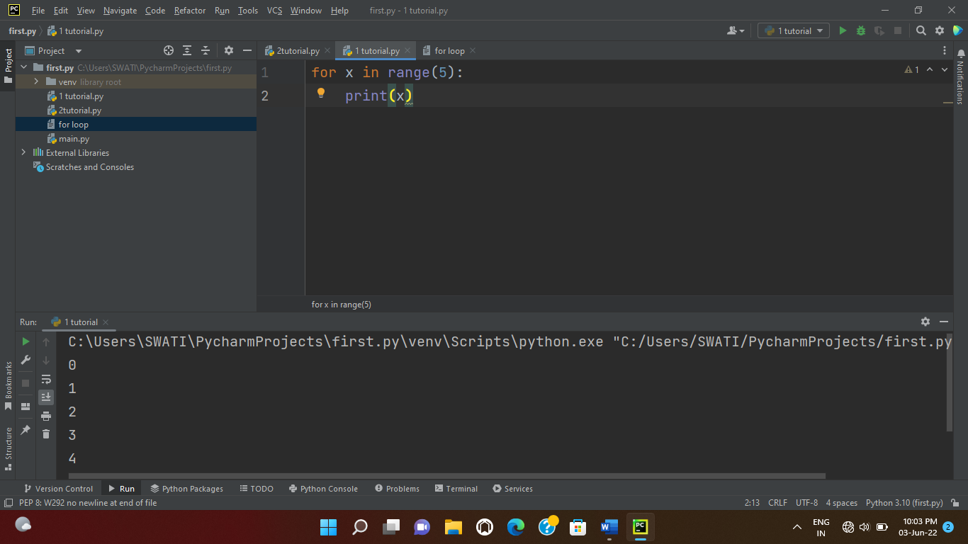

* **For loop using string ():-**

for a in "Orange":  
 print(a)

* + **Output:-**

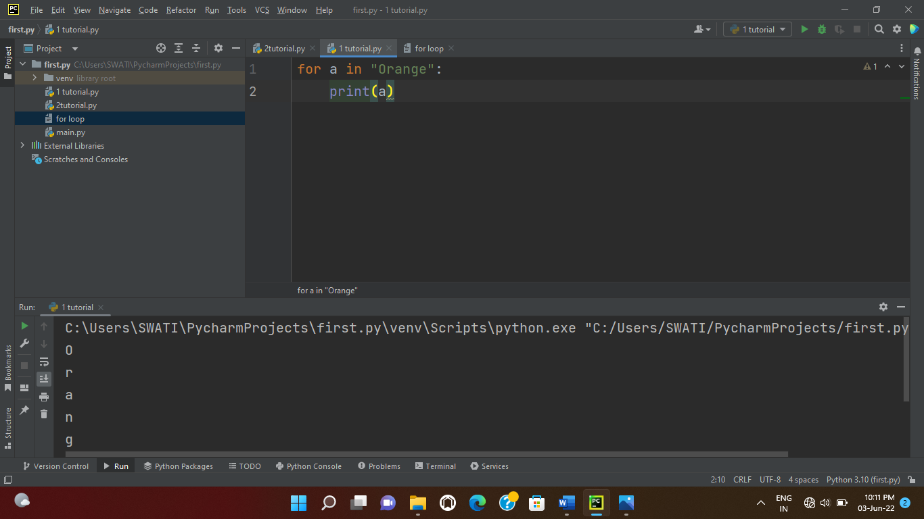

* **For loop using list:-**

mystr=["apple","orange","watermelon","cherry"]  
for x in mystr:  
 print(x)

* + **Output:-**

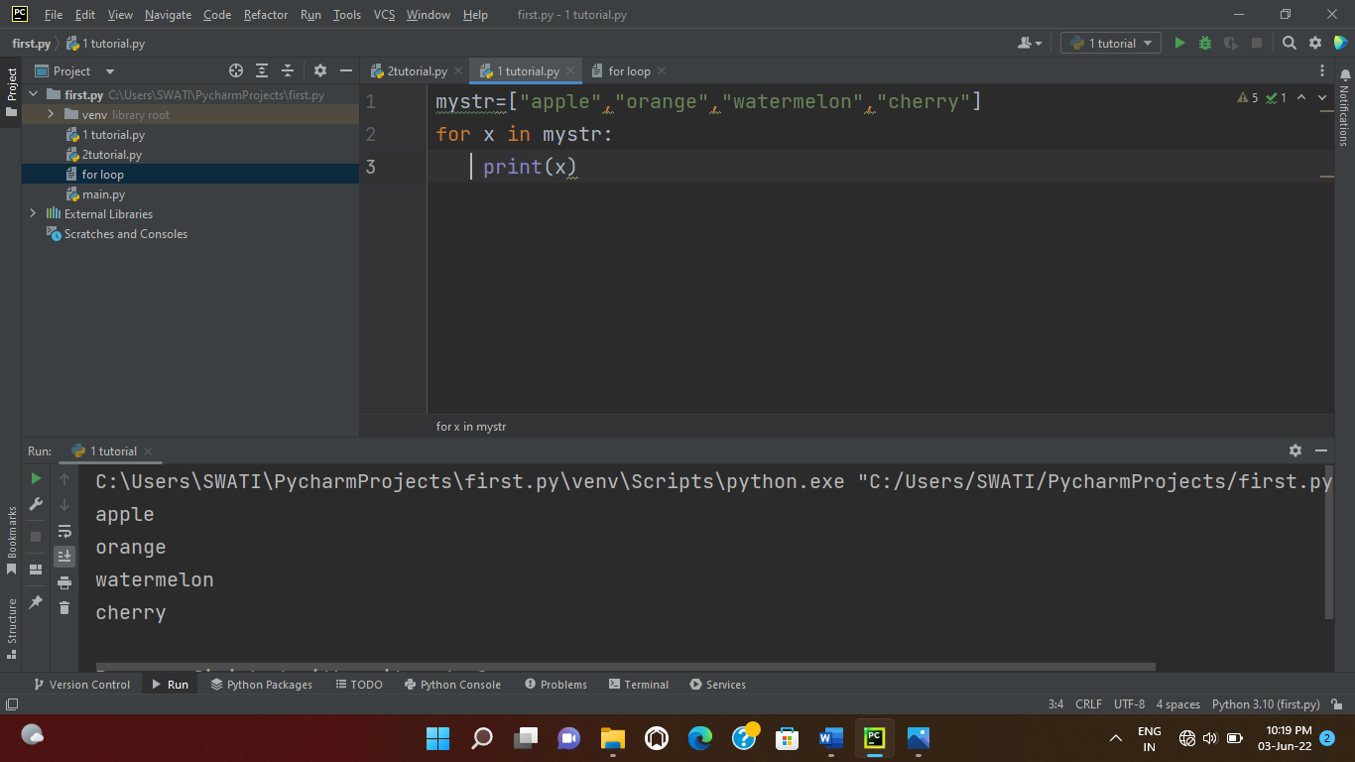

* **For loop using tuple:-**

mystr=[1,2,3,4,5,6,7]

for x in mystr:  
 print(x)

* + **Output**:-

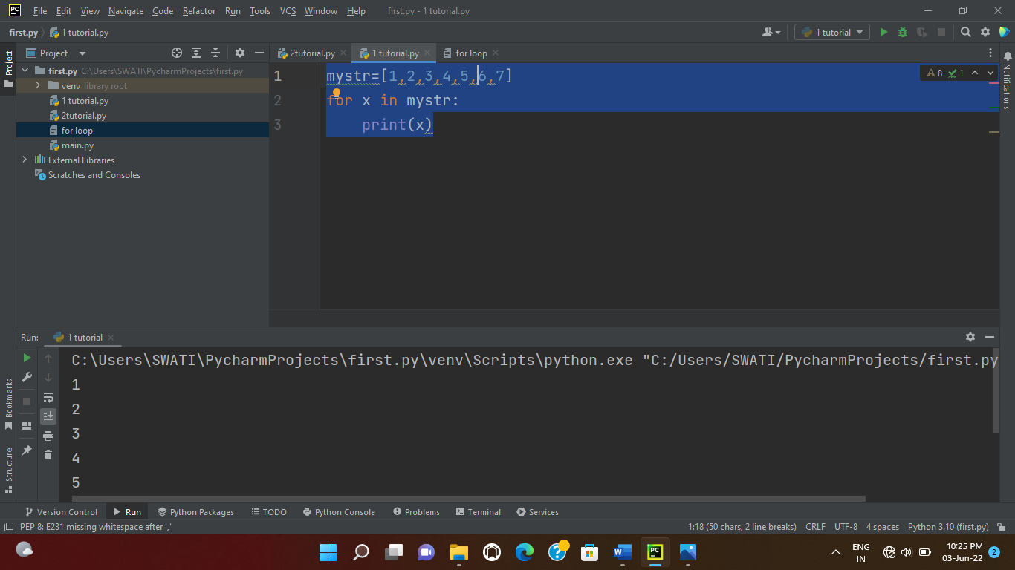

* **For loop using dictionary:-**

stud={'Name':'Swati','RollNo.':97,'class':'FYMCA'}  
emp1={'Name':'Swati','ID':98,'Department':'IT'}  
person={'Name':'Swati','City':'Jalgaon','GFemale'}  
for x in stud.items():  
 print(x)  
for x in emp1.items():  
 print(x)

for x in person.items():

print(x)

* + **Output:-**

